Rymbayeva Anelya, 2 course, Lab1 – IT Infrastructure

1. Click S1 and then the CLI Tab. Press ENTER.

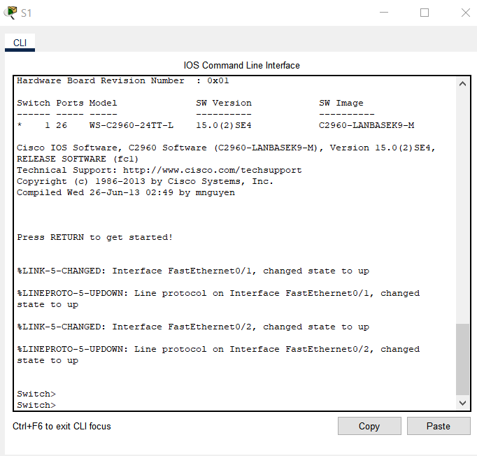

1. Enter privileged EXEC mode by entering the enable command.



1. Enter the show running-config command.
2. How many Fast Ethernet interfaces does the switch have?
3. How many Gigabit Ethernet interfaces does the switch have?
4. What is the range of values shown for the vty lines?
5. Which command will display the current contents of non-volatile random-access memory(NVRAM)?

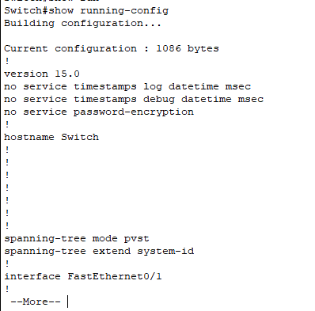

1. To configure parameters on a switch, you may be required to move between various configuration modes. Notice how the prompt changes as you navigate through the switch.

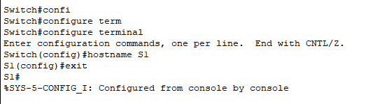

1. To secure access to the console line, access config-line mode and set the console password to letmein.

Why is the login command required?

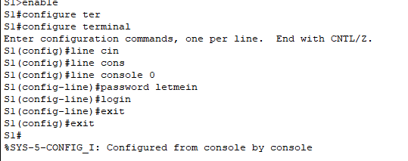

1. Exit privileged mode to verify that the console port password is in effect.

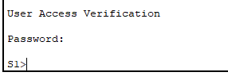

1. Enter the exit command again to log out of the switch.

Press <enter> and you will now be asked for a password.

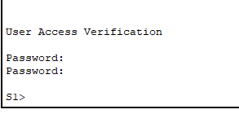

1. Verify your configuration by examining the contents of the running-configuration file.

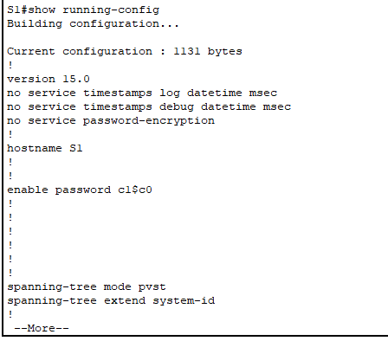

1. The enable password should be replaced with the newer encrypted secret password using the enable secret command. Set the enable secret password to itsasecret.

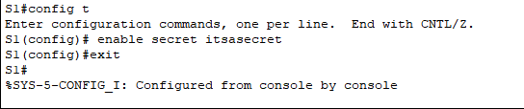

1. What is displayed for the enable secret password?

Why is the enable secret password displayed differently from what we configured?

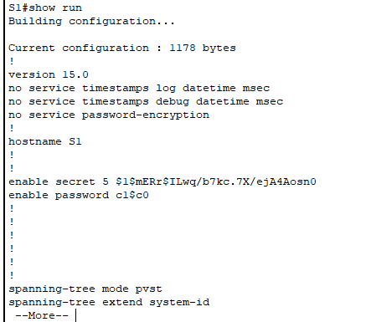

1. We will now encrypt these plain text passwords using the service password-encryption command.

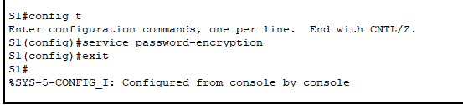

1. Enclose the banner text in quotations or use a delimiter different from any character appearing in the MOTD string. When will this banner be displayed? Why should every switch have a MOTD banner?

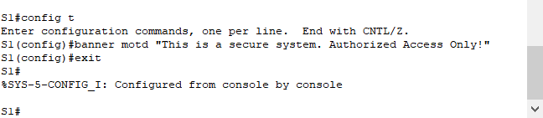

1. Save the configuration file. You have completed the basic configuration of the switch. Now back up the running configuration file to NVRAM to ensure that the changes made are not lost if the system is rebooted or loses power.

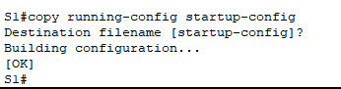

1. What is the shortest, abbreviated version of the copy running-config startup-config command?

**Answer: “copy run start”**

1. Examine the startup configuration file.

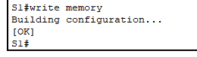

1. Which command will display the contents of NVRAM?

**Answer: “show startup-config”**

1. Are all the changes that were entered recorded in the file?

**Answer**: Yes, it is the same as the running configuration**.**

1. Why is the login command required? **Answer: In order for the password checking process to work, it requires both the login and password commands.**
2. **Configure S2 with the following parameters:**

Device name: S2

Protect access to the console using the letmein password

Configure an enable password of c1$c0 and an enable secret password of itsasecret

Configure an appropriate message to those logging into the switch

Encrypt all plain text passwords

Ensure that the configuration is correct

Save the configuration file to avoid loss if the switch powered down.

